Ideation Phase
Empathize & Discover

Date | 19 October 2026
Team ID
Project Name | StaffSync
Maximum Marks | 4 Marks

Empathy Map Canvas:
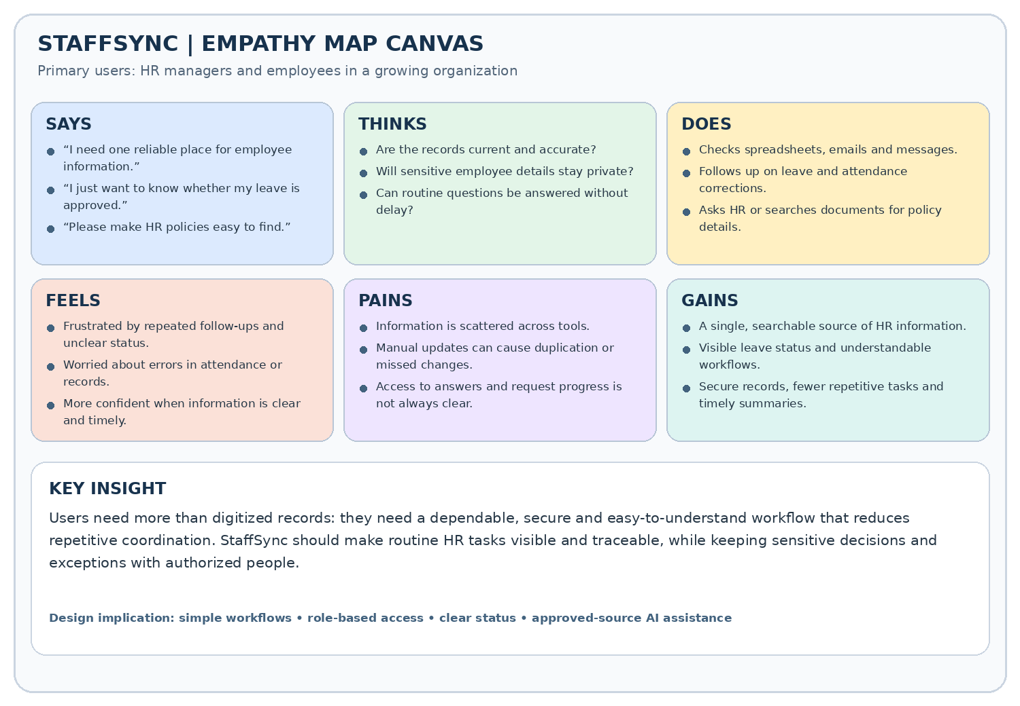
Empathy map for HR managers and employees using StaffSync. The key needs are reliable employee data, clear leave and attendance workflows, quick access to HR policies, and visible request status. StaffSync is designed to reduce repetitive administration while keeping sensitive information access-controlled and important HR decisions with people.

Reference: https://www.mural.co/templates/empathy-map-canvas

